301 Tuam Street
Otautahi, Christchurch 8011
Phone (03) 365 3139
Fax (03) 366 8535

Email manager@cch.org.nz
www.cch.org.nz

Visit www.cch.org.nz
to take a 3D tour of CCH’s Meeting Spaces

VENUE CHARGES
Not-For-Profit Rates - January 2021

Christchurch Community House has a number of meeting and interview room options. These are available to any not-for-profit and we have two pricing plans – Members & Non Member Rates. We would encourage groups using CCH’s venues on a regular basis to join CCH as members so they can utilise the meeting space at members’ rates.

Meeting Room 1 (the large meeting room)
- Separate access
- Plenty of space for up to 50 people (limited only by the number of chairs in the room)
- Sound system with hand held and lapel microphone
- State of the art hearing loop
- Ceiling mounted data projector and electronic projection screen
- Electronic whiteboard
- Telephone available to make local calls. Pin number can be arranged for toll calls. Telephone conferencing facilities can also be arranged upon request.
- Wireless internet available on request
- Fully equipped kitchenette – Rapid boil unit, dishwasher, microwave, fridge, cutlery, crockery, serving dishes, etc
- Independent heating and cooling system with fresh air intake
- Fantastic natural light
- Access to a small outdoor seating area
- Fully wheelchair accessible
 | Hourly | Half Day (3-4hrs) | Full day (5-8hrs)
Members | $40 + GST | $120 + GST | $200 + GST
Not-For-Profit | $50 + GST | $150 + GST | $250 + GST
** Hearing Loop, Sound System & Data Projector included in these rates.
**CCH Trust reserves the right to charge a 20% cancellation fee if reasonable notice of cancellation is not received

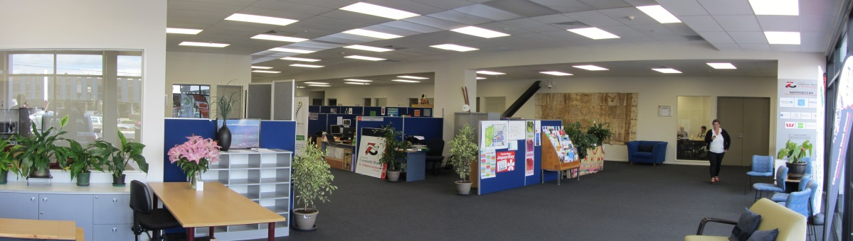

Meeting Room 2
- Seats 30 people (theatre style seating) or 16 around a board room table (using our kite tables that can be easily set up by one person)
- Electronic whiteboard
- LCD TV for data presentations, Skype or Zoom Conferencing included in room hire. We can also provide a short throw Data Projector as an optional extra to provide a larger image.
- Telephone available to make local calls. Pin number can be arranged for toll calls. Telephone conferencing facilities can also be arranged upon request.
- Wireless internet available on request.
- Fully equipped kitchenette – Rapid boil unit, dishwasher, microwave, fridge, cutlery, crockery, serving dishes, etc
- Independently controlled heat pump
- Fully wheelchair accessible
 | Hourly | Half Day (3-4hrs) | Full day (5-8hrs)
Members | $20 + GST | $60 + GST | $100 + GST
Not-For-Profit | $25 + GST | $75 + GST | $125 + GST
**CCH Trust reserves the right to charge a 20% cancellation fee if reasonable notice of cancellation is not received

Pop Up Meeting Spaces - Office 6 & 15
- Basic Meeting Space for up to 15 people
- Portable Whiteboard
- Wireless internet access available on request
- Independently controlled heat pump
- Fully wheelchair accessible
 | Hourly | Half Day (3-4hrs) | Full day (5-8hrs)
Members | $15 + GST | $45 + GST | $75 + GST
Not-For-Profit | $20 + GST | $60 + GST | $100 + GST
**CCH Trust reserves the right to charge a 20% cancellation fee if reasonable notice of cancellation is not received

Interview Rooms
- 3 room options available
- Seats up to 6 people
- Telephone for local calls. Pin number can be arranged to make toll calls. Teleconferencing available on request.
- Wall mounted whiteboard
- Wireless internet access available on request
- Independently controlled heat pump
- Fully wheelchair accessible
 | Hourly | Half Day (3-4hrs) | Full day (5-8hrs)
Members | $10 + GST | $30 + GST | $50 + GST
Not-For-Profit | $15 + GST | $45 + GST | $75 + GST
** CCH Tenants can access these rooms at no charge (based on fair and reasonable usage for shared space)
**CCH Trust reserves the right to charge a 20% cancellation fee if reasonable notice of cancellation is not received

Hot Desks
- 2 options available in open plan office area
- Height Adjustable Sit/Stand Desk.
- Use your own laptop or borrow one from CCH
- Telephone for local calls. Pin number can be arranged to make toll calls. Telephone conferencing facilities can also be arranged upon request.
 | Hourly | Half Day (3-4hrs) | Full day (5-8hrs)
Members | $5 + GST | $15 + GST | $25 + GST
Not-For-Profit | $10 + GST | $30 + GST | $50 + GST
** CCH Tenants can access these rooms at no charge (based on fair and reasonable usage for shared space)
**CCH Trust reserves the right to charge a 20% cancellation fee if reasonable notice of cancellation is not received
OPTIONAL EXTRAS
To ensure your meeting is a success we can offer you the following additional services:
 | Members | Not-For-Profit
Data Projector | $15.00 + GST | $25.00 + GST
UFB Wifi Single User  Multi User (Max 20 devices) | Free  $4.00/Gb + GST | Free  $5.00/Gb + GST
Photocopying A4 B&W  A4 Colour | $0.10 + GST  $0.40/Gb + GST | $0.15 + GST  $0.60/Gb + GST
Catering | See page 3 for options

CATERING
Christchurch Community House is delighted to offer you the following catering options.
Our preferred caterers have been carefully selected to provide you with good food at a reasonable price and are familiar with all our venues.
All provide a delivery service and CCH Reception can supply you with a copy of their current menus.

CCH’s Bottomless  Tea & Coffee  Add to CCH Invoice | We can set up any of our venues with basic tea and coffee making facilities for your guests to enjoy:  Member Not-For-Profit  Half Day $1.50/pp + GST $2.00/pp + GST  Full Day $2.50/pp + GST $3.00/pp + GST  Minimum charge of $15+GST
Add to CCH Invoice  Please contact CCH Reception for order form | With over 30 years of experience, Canterbury owned and operated Victoria Food Service has got you covered. Choose from our range of deliciously different menus that we have created specifically for Christchurch Community House or design your own. We create everything to order ensuring it’s locally sourced, fabulously fresh and infused with flavour. Your catering requirements can be added your venue invoice. Simply complete the form CCH staff provide with our menu options.  Corporate catering, big and small - it’s what we do best.
Add to CCH Invoice | The Sauce Kitchen is a modern catering kitchen. Our catering is fresh and chic with many health options available for gluten free, vegetarian & vegan. We are proud to be free range. The Sauce Kitchen sources premium ingredients from Canterbury: Westwood Genuine Free Range chicken from West Melton, free range eggs from Jock in Waimate, artisan chorizo from Mariano Salmon & bacon from Holy Smoke in Woolston, small goods from Euro Deli Meats, pork from Freedom Farms & our wonderful butcher is Peter Timms. We lost our High street espresso bar in the earthquakes and have re- established The Sauce Kitchen as a catering kitchen providing something unique for Christchurch Community House’s clients
Can Do Catering is one of Christchurch’s newest caterers for business and or social functions (e.g. Board meetings, staff training and workshops etc.).
Can Do Catering is a social enterprise business that provides real employment for younger adults with significant physical impairments. Our vision is for you to hear their story through the great food they provide for you. Can Do Catering is a division of the Laura Fergusson Trust (Canterbury) and shares the Trust’s vision of providing ordinary life opportunities for its clients. Our food is of a very high quality, includes organic ingredients from our own garden and is competitively priced. Delivery is free, and we are always willing to discuss and cater for any individual requirements.

You are welcome to use our preferred caters, select one of your own, or self-cater for your event.
MEMBERSHIP
If you are a not-for-profit organisation and planning to use our facilities on a regular basis we would recommend that you consider joining Christchurch Community House as a member. Annual subscription is affordable and based on an annual subscription
Membership (Offered exclusively to Community groups) | S100.00pa + GST

Membership Applications Forms are available from CCH Reception, can be emailed to you or downloaded from our Website.

OFFICE SPACE
Join 30 other Not-For-Profit Community Organisations in a collaborative, co-sharing workspace that has been specifically designed to meet the needs of the community sector. Sharing resources and facilities designed to keep your overheads to a minimum.
Don’t work in isolation. Become part of Community House. Increase your profile and enjoy the collaborative environment making a positive difference in the community.

We have tailored a number of packages to meet the needs of most community groups or we can customise a package specifically for you. Options include:

Virtual Office @ $75 + GST per month
This service replaces Christchurch Community House’s Room-In-A-Box Services and gives smaller groups a presence in the House without an office. Service is available to members upon acceptance of their application at a cost of $70+GST per month. Virtual Office Holders can use CCH as their mailing address, can access CCH’s reception and other services. As part of the package they also receive $50+GST of venue usage per month which can be used in any of CCH’s meeting spaces. Additional meeting space will be charged at our normal members rates. Storage space can also be arranged at an additional cost.

Open Plan Office Space from $266.50 + GST per month
Our standard footprint for open plan space is 9m2. This provides sufficient space for one staff member with access to more space, resources and facilities when required.

Private Office Space from $403.00 + GST per month
These private walled office spaces are well appointed and available in different sizes to meet the needs of both small and large community groups.

Shared or Co-Working Space
Ideal for groups working part time that may not be able to afford or need a full time space. Groups can work together within the same space or on different days. Each tenant has the same rights and access to services as our full time tenants. We work hard to make sure the groups are compatible and the relationship is working well.

Central City Hub
Since the earthquakes ripped the heart out of our city a number of groups have relocated to the suburbs but need access to a central city hub to meet clients and complete administration tasks without spending large amounts of time in traffic jams. This concept also works well for organisations working from home but need a central point to meet clients and collaborate and network with other like-minded people.

Storage Space
Ideal for resources and/or archives in a secure shared storage room. Combination of lockable or open shelved storage units available.
Modern central City premises

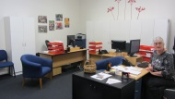
Private Office

Open Plan

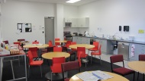
Lunch Room

Shared Reception

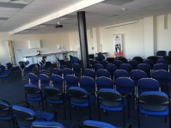
Meeting Room 1

Please talk to our friendly staff about the application process.

