301 Tuam Street
Otautahi, Christchurch 8011
Phone (03) 365 3139
Fax (03) 366 8535

Email manager@cch.org.nz
www.cch.org.nz

Visit www.cch.org.nz
to take a 3D tour of CCH’s Meeting Spaces

VENUE CHARGES
Commercial Entities - January 2021

Christchurch Community House is home to 30 Not-For-Profit Community organisations sharing resources and facilities. This means we have a number of meeting and interview room options. These are available to both not-for-profits and commercial entities. For commercial entities we have a two teir pricing system – our standard commercial rate and our special supporters’ rate. We would encourage groups using CCH’s venues on a regular basis to join CCH Supporters Programme so you can utilise the meeting spaces at preferential rates.

Meeting Room 1 (the large meeting room)
- Separate access
- Plenty of space for up to 50 people (limited only by the number of chairs in the room)
- Sound system with hand held and lapel microphone
- State of the art hearing loop
- Ceiling mounted data projector and electronic projection screen
- Electronic whiteboard
- Telephone available to make local calls. Pin number can be arranged for toll calls. Telephone conferencing facilities can also be arranged upon request.
- Wireless internet available on request
- Fully equipped kitchenette – Rapid boil unit, dishwasher, microwave, fridge, cutlery, crockery, serving dishes, etc
- Independent heating and cooling system with fresh air intake
- Fantastic natural light
- Access to a small outdoor seating area
- Fully wheelchair accessible
 | Hourly | Half Day (3-4hrs) | Full day (5-8hrs)
Supporter | $80 + GST | $240 + GST | $400 + GST
Commercial | $100 + GST | $300 + GST | $500 + GST
** Hearing Loop, Sound System & Data Projector included in these rates.
**CCH Trust reserves the right to charge a 20% cancellation fee if reasonable notice of cancellation is not received

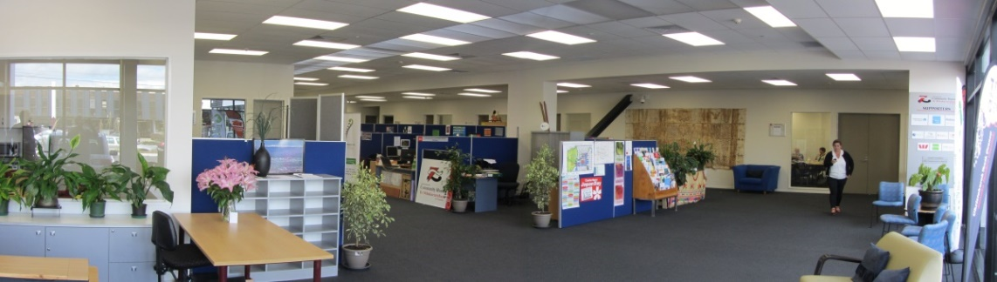
Meeting Room 2
- Seats 30 people (Theatre style seating) or 16 around a board room table (using our kite tables that can be easily setup by one person)
- Electronic whiteboard
- LCD TV for data presentations, Skype or Zoom Conferencing included in room hire. We can also provide a short throw Data Projector as an optional extra to provide a larger image.
- Telephone available to make local calls. Pin number can be arranged for toll calls. Telephone conferencing facilities can also be arranged upon request.
- Wireless internet available on request.
- Fully equipped kitchenette – Rapid boil unit, dishwasher, microwave, fridge, cutlery, crockery, serving dishes, etc
- Independently controlled Heatpump
- Fully wheelchair accessible
 | Hourly | Half Day (3-4hrs) | Full day (5-8hrs)
Supporter | $40 + GST | $120 + GST | $200 + GST
Commercial | $50 + GST | $150 + GST | $250 + GST
**CCH Trust reserves the right to charge a 20% cancellation fee if reasonable notice of cancellation is not received

Pop Up Meeting Spaces - Office 6 & 15
- Basic Meeting Space for up to 15 people
- Portable Whiteboard
- Wireless internet access available on request
- Independently controlled heat pump
- Fully wheelchair accessible
 | Hourly | Half Day (3-4hrs) | Full day (5-8hrs)
Members | $30 + GST | $90 + GST | $150 + GST
Not-For-Profit | $40 + GST | $120 + GST | $200 + GST
**CCH Trust reserves the right to charge a 20% cancellation fee if reasonable notice of cancellation is not received

Interview Rooms
- 3 room options available
- Seats up to 6 people
- Telephone for local calls. Pin number can be arranged to make toll calls. Teleconferencing available on request.
- Wall mounted whiteboard
- Wireless internet access available on request
- Independently controlled Heatpump
- Fully wheelchair accessible
 | Hourly | Half Day (3-4hrs) | Full day (5-8hrs)
Supporter | $20 + GST | $60 + GST | $100 + GST
Commercial | $30 + GST | $90 + GST | $150 + GST
**CCH Trust reserves the right to charge a 20% cancellation fee if reasonable notice of cancellation is not received

CCH SUPPORTS CLUB
If you are a Commercial Entity and planning to use our facilities on a regular basis we would recommend that you consider joining Christchurch Community House as a supporter. Annual Subscription is affordable and unlocks our supports rates. Christchurch Community House is home to 30 Not-For-Profit Groups representing a wide cross section of the community. Your subscription is used to help fund the work of Christchurch Community House Trust and the large number of community organisations that benefit from our services.
Annual Subscription | $200.00 + GST
Please talk to our friendly staff about the application process.
OPTIONAL EXTRAS
To ensure your meeting is a success we can offer you the following optional extras:
 | Supporter | Commercial
Data Projector | $15.00 + GST | $25.00 + GST
UFB Wifi Single Use Multi User (Max 20 devices) | Free  $5.00/day + GST | Free  $10.00/day + GST
Photocopying A4 B&W  A4 Colour | $0.15 + GST  $0.60/Gb + GST | $0.20 + GST  $0.80/Gb + GST
CATERING
Christchurch Community House is delighted to offer you the following catering options
Our preferred caterers have been carefully selected to provide you with good food at a reasonable price and are familiar with all our venues.
All our preferred caterers provide a delivery service and CCH Reception can supply you with a copy of their current menus
CCH’s Bottomless  Tea & Coffee  Add to CCH Invoice | We can setup any of our venues with basic tea and coffee making facilities for your guests to enjoy:  Supporter Commercial  Half Day $2.00/pp + GST $2.50/pp + GST  Full Day $3.00/pp + GST $4.00/pp + GST  Minimum charge of $15+GST
Add to CCH Invoice  Please contact CCH Reception for order form |  | With over 30 years of experience, Canterbury owned and operated Victoria Food Service has got you covered. Choose from our range of deliciously different menus that we have created specifically for Christchurch Community House or design your own. We create everything to order ensuring it’s locally sourced, fabulously fresh and infused with flavour. Your catering requirements can be added your venue invoice. Simply complete the form CCH staff provide with our menu options.  Corporate catering, big and small - it’s what we do best.
Add to CCH Invoice |  | The Sauce Kitchen is a modern catering kitchen. Our catering is fresh and chic with many health options available for gluten free, vegetarian & vegan. We are proud to be free range. The Sauce Kitchen sources premium ingredients from Canterbury: Westwood Genuine Free Range chicken from West Melton, free range eggs from Jock in Waimate, artisan chorizo from Mariano Salmon & bacon from Holy Smoke in Woolston, small goods from Euro Deli Meats, pork from Freedom Farms & our wonderful butcher is Peter Timms. We lost our High street espresso bar in the earthquakes and have re- established The Sauce Kitchen as a catering kitchen providing something unique for Christchurch Community House’s clients
Can Do Catering is one of Christchurch’s newest caterers for business and or social functions (e.g. Board meetings, staff training and workshops etc.).
Can Do Catering is a social enterprise business that provides real employment for younger adults with significant physical impairments. Our vision is for you to hear their story through the great food they provide for you. Can Do Catering is a division of the Laura Fergusson Trust (Canterbury) and shares the Trust’s vision of providing ordinary life opportunities for its clients. Our food is of a very high quality, includes organic ingredients from our own garden and is competitively priced. Delivery is free, and we are always willing to discuss and cater for any individual requirements.

You are welcome to use our preferred caters, select one of your own, or self-cater for your event.

